

**Tribhuvan University**

**Faculty of Humanities and Social Sciences**

**LAPTOP PRICE PREDICTION SYSTEM**

**A PROJECT PROPOSAL**

**Submitted to**

**Department of Computer Application**

**Patan Multiple Campus**

**Patan Dhoka, Lalitpur**

***In partial fulfillment of the requirements for the Bachelors in Computer Application***

**Submitted by**

**Ayush Silwal**

**BCA 6th Semester**

**University SN: 6-2-22-11-2020**

**Symbol No.: 2202013**

Table of Content

1. Introduction 1

2. Problem Statement 1

3. Objectives 2

4. Methodology 2

a) Requirement Identification 3

i) Study of Existing System 3

ii) Literature Review 3

.iii) Requirements Analysis 3

b) Feasibility Study 5

i) Technical Analysis 5

ii) Operational Analysis 5

iii) Economic Analysis 5

iv)Schedule Analysis 5

c) High Level Design of System 6

i) Flowchart 6

5) Gantt Chart 7

6) Expected Outcome 7

7) References 8

**List of Figure**

Figure 1: Waterfall Model for Laptop Price Prediction System 2

Figure 2: Use Case Diagram for Laptop Price Prediction System 4

Figure 3: Flowchart for Laptop Price Prediction System 6

Figure 4: Gantt chart for Laptop Price Prediction System 7

# 1. Introduction

In today's technology-driven world, laptops are essential for work, education, and entertainment. However, with the vast array of brands, models, and specifications available, determining the right price for a laptop can be challenging for users. Users need to get good value for their money. The Laptop Price Prediction System is an application developed to predict laptop prices based on their specifications, making the purchasing and pricing process more informed and efficient. This system works by analyzing features such as brand, processor type, RAM size, storage capacity, screen size, and other relevant attributes to estimate the price of the laptop accurately. This saves time and money for users utilizing the system.

By using the Laptop Price Prediction System, users can make smarter decisions when buying a laptop. They can quickly find out if a laptop is worth its price by comparing its specifications to similar models. This tool simplifies the buying process, ensuring users don't overpay for features they don't need or miss out on important ones. Ultimately, this system helps users feel confident and satisfied with their laptop purchases, knowing they have made a well-informed choice.

# 2. Problem Statement

In today's technology-driven world, laptops have become essential tools for both personal and professional use. With a wide range of brands, models, and specifications available in the market, predicting the price of a laptop based on its features can be a challenging yet valuable task. An accurate price prediction model can assist users in making informed purchasing decisions and help retailers in pricing strategies.

As of now, there doesn't appear to be a dedicated laptop price prediction system specifically developed for the Nepali market. Most existing solutions for laptop pricing in Nepal are focused on listing current prices and specifications, often provided by e-commerce platforms and local retailers. These platforms do not typically offer predictive analytics or future price prediction capabilities.

# 

# 3. Objectives

The main objectives of Laptop Price Prediction System are as below:

* To predict price of laptop for users.
* To give predicted history to users

# 4. Methodology

The methodology behind the Laptop Price Prediction System involves collecting a large dataset of laptop prices and their specifications. The data is then preprocessed to clean and organize it, removing any inconsistencies or errors. Next, the system uses machine learning algorithms to analyze the data. Key features like brand, processor type, RAM size, storage capacity, and screen size are used as input variables. The machine learning model is trained on this data to learn patterns and relationships between these features and the laptop prices. Once trained, the model can predict the price of a laptop based on its specifications. This prediction is continually refined as the system is updated with new data, ensuring accurate and up-to-date price estimates.

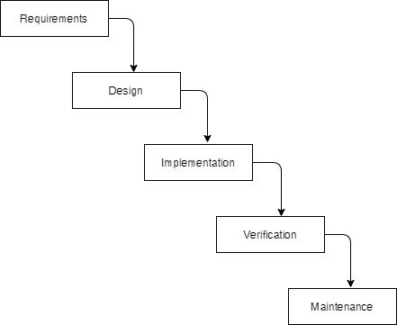

**Figure.1: Waterfall Model for Laptop Price Prediction System**

## 

## a) Requirement Identification

### i) Study of Existing System

Currently, several existing systems and websites provide price comparisons and reviews for laptops. These systems often rely on static databases or user-submitted information, which may not always be up-to-date or accurate. Websites like Amazon, Best Buy, and other retail platforms offer price comparisons and user reviews, but they do not necessarily provide price predictions based on specific laptop specifications.

Price aggregation websites like PriceGrabber and Google Shopping compile prices from various sellers, allowing users to compare costs. However, these systems do not predict prices based on detailed specifications but rather show current market prices from different sources. While useful, these platforms require users to manually sift through various options and may not offer personalized insights based on individual needs and preferences.

### ii) Literature Review

Currently, there is a lack of specific web-based systems dedicated to laptop price prediction in Nepal. While existing e-commerce platforms, like Amazon and Best Buy, focus on real-time pricing adjustments based on market demand and competitor pricing, they do not offer long-term price forecasting using machine learning. Academic research has explored various machine learning techniques, including regression algorithms and ensemble methods, for price prediction based on historical data and product specifications. Studies have demonstrated the effectiveness of these techniques in predicting prices for consumer electronics, highlighting the potential for developing a Laptop Price Prediction System that provides accurate long-term price estimates tailored to the Nepali market

### .iii) Requirements Analysis

For this system, requirements are basically identified through functional and nonfunctional requirements.

**Functional Requirements**

**For Users:**

• System should allow users to input laptop specifications

• System should allow users to see there predicted history.

**For System**

• System should predict laptop prices based specifications.

**For Admin**

• System should allow admin to view prediction history.

• System should allow admin to monitor user’s data.

**Use Case Diagram**

In Laptop Price prediction System, the use case diagram consists of a user and admin where user is allowed to register and login to the system. Users are allowed to enter specification.

Likewise, admin is allowed to login to the system. Admin is allowed to manage information of the users, and the view prediction history. Admin is responsible to manage the website.

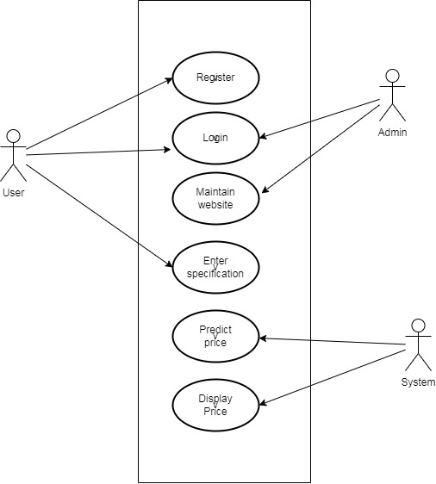

**Figure 2: Use Case Diagram for Laptop Price Prediction System**

**Non- Functional Requirements**

**Security:** Implement secure user authentication and data encryption for protecting user information.

**Availability:** Ensure the system is accessible 24/7 for users to input specifications and receive predictions.

**Performance:** Optimize system performance to handle large datasets and provide fast response times.

**Reliability:** Ensure the system operates without failures to maintain data integrityand user trust.

## b) Feasibility Study

### i) Technical Analysis

The project's technical feasibility is supported by the availability of suitable programming languages and libraries capable of achieving the desired results. The system will leverage existing technology infrastructure and meet specific requirements for accurate laptop price prediction based on detailed specifications and historical data.

### ii) Operational Analysis

The Laptop Price Prediction System will encompass all necessary features for efficient functionality, ensuring ease of use and operational success. The system will be user-friendly, facilitating seamless navigation and utilization for users seeking to make informed laptop purchasing decisions.

### iii) Economic Analysis

The proposed system is economically viable and cost-effective, utilizing open-source tools and resources. There will be no need for additional hardware or software deployment post-completion, leveraging existing infrastructure effectively.

### iv)Schedule Analysis

The development of the Laptop Price Prediction System will adhere to a predefined schedule, ensuring timely completion within the allocated timeframe without exceeding the planned duration.

## c) High Level Design of System

### i) Flowchart

Random forest is a commonly-used machine learning algorithm, trademarked by Leo Breiman and Adele Cutler that combines the output of multiple decision trees to reach a single result. Its ease of use and flexibility have fueled its adoption, as it handles both classification and regression problems.

**Algorithm for Random Forest Work:**

Step 1: Select random K data points from the training set.

Step 2: Build the decision trees associated with the selected data points.

Step 3: Choose the number N for decision trees that you want to build.

Step 4: Repeat Step 1 and 2.

Step 5: For new data points, find the predictions of each decision tree, and assign the new data points to the category that wins the majority votes.

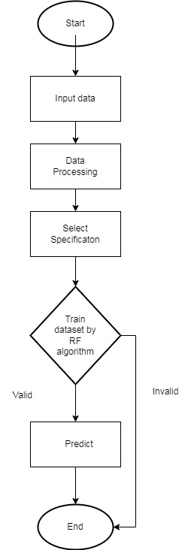

**Figure 3: Flowchart of the system** **for Laptop Price Prediction System**

# 5) Gantt Chart

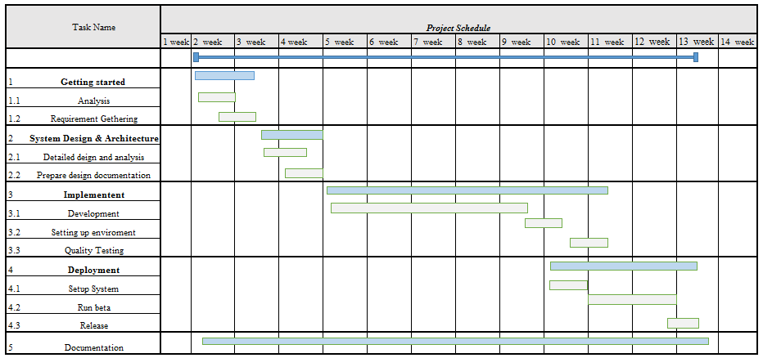

**Figure 4: Gantt chart for Laptop Price Prediction System**

# 6) Expected Outcome

After the successful completion of the project, it will be expected to have a system that will predict the price of laptop according to user specification. This system should be able to manage the information and details of the users. The user should be able to see there predicted history. The website will provide user-friendly interface show it is easier for them to enter specification to get prediction.

# 7) References

[1] IBM, "Random Forest," IBM, Available: <https://www.ibm.com/topics/random-forest> [Accessed: 07 06 2024]

[2]MDRIAZHASA,"LaptopPricePredictionSystem,"SlideShare,Available: https://www.slideshare.net/slideshow/laptop-price-prediction-system [Accessed 07 06 2024]

[3] GeeksforGeeks, "Random Forest Algorithm in Machine Learning," GeeksforGeeks, Available: https://www.geeksforgeeks.org/random-forest-algorithm-in-machine-learning/. [Accessed 07 06 2024]